

K.R. MANGALAM UNIVERSITY

Name of Student – Rakshita

Roll NO. – 2301201087
Course Code – ENCA351

Department – School of Engineering & Technology Name of Faculty – Dr. Aarti
Name of subject- Design and Analysis of Algorithms Lab
Analyzing and Visualizing Recursive Algorithm Efficiency

Introduction
In computer science, analyzing the efficiency of algorithms is important because it helps us choose the best approach for solving problems. Recursive and iterative solutions often
behave differently as input size grows.
The goal of this project is to implement several algorithms, measure their time and space performance, and compare theoretical vs. experimental results.

Algorithm Implemented

The following algorithms were implemented and analyzed:
  - Fibonacci (Recursive and Dynamic Programming)
  - Merge Sort
  - Quick Sort
  - Insertion Sort
  - Bubble Sort
  - Selection Sort
  - Binary Search

Fibonacci (Recursive)

Theory: Calls itself repeatedly to compute the nth number. Simple but inefficient due to repeated calculations.
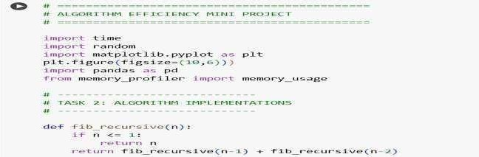
Complexity: Time O(2^n), Space O(n).
Fibonacci (Dynamic Programming)
Theory: Uses iteration and stores results. Much more efficient. Complexity:
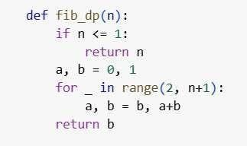
Time O(n), Space O(1).

Merge Sort
Theory: Divide and conquer algorithm. Splits, sorts, and merges.
Complexity: Time O(n log n), Space O(n).
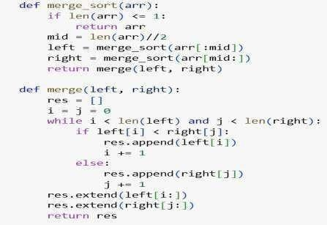
Quick Sort
Theory: Divide and conquer. Partitions around a pivot.
Complexity: Average O(n log n), Worst O(n^2), Space O(log n).
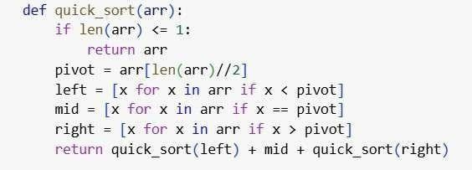

Insertion Sort
Theory: Builds sorted list one element at a time.
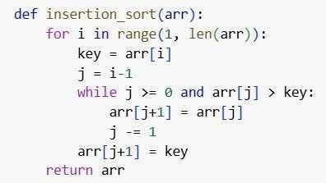
Complexity: Best O(n), Worst O(n^2), Space O(1).

Bubble Sort
Theory: Compares adjacent elements and swaps. Complexity:
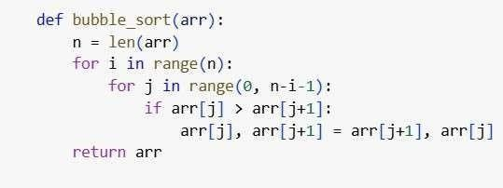
Time O(n^2), Space O(1).
Selection Sort
Theory: Finds minimum and places it at the beginning. Complexity:
Time O(n^2), Space O(1).
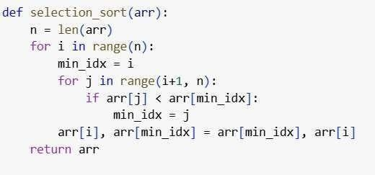

Binary Search
Theory: Efficiently halves the search space in sorted arrays.
Complexity: Time O(log n), Space O(1).
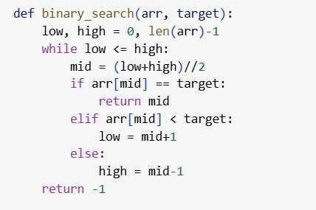
Experimental Profiling & Visualization
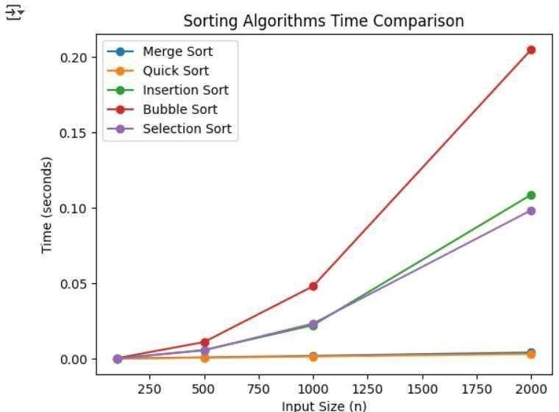
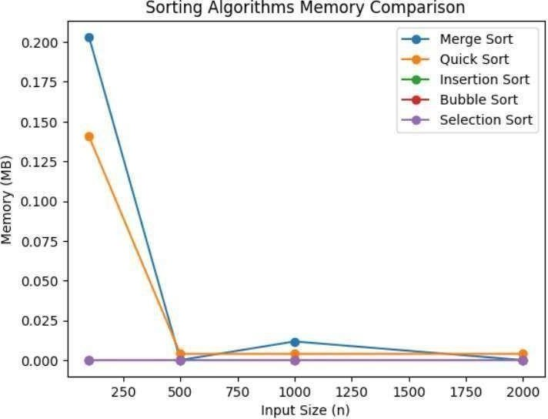
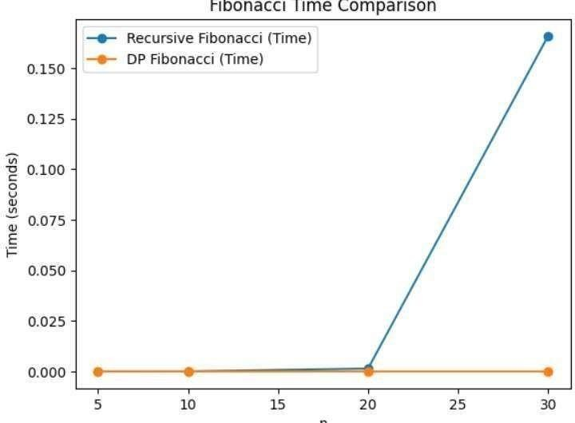
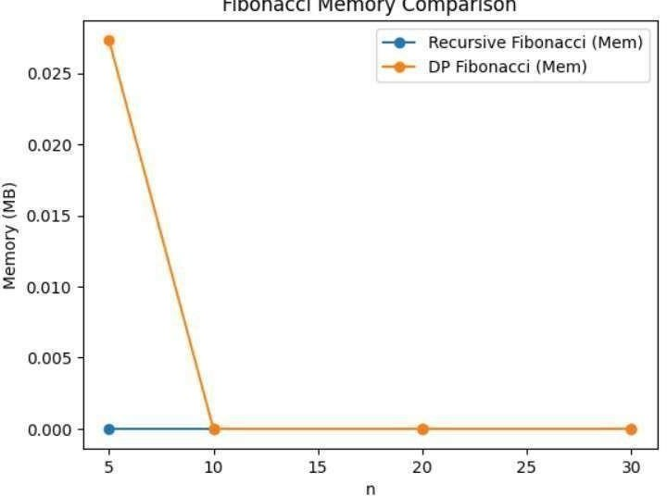
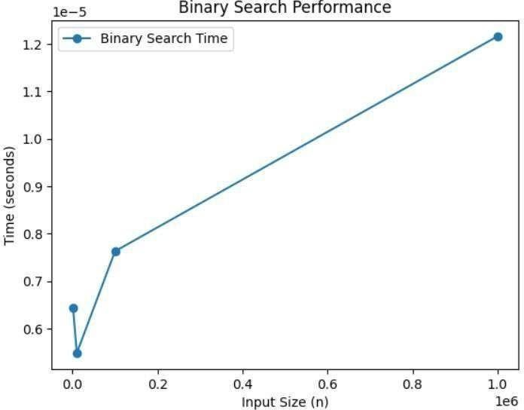
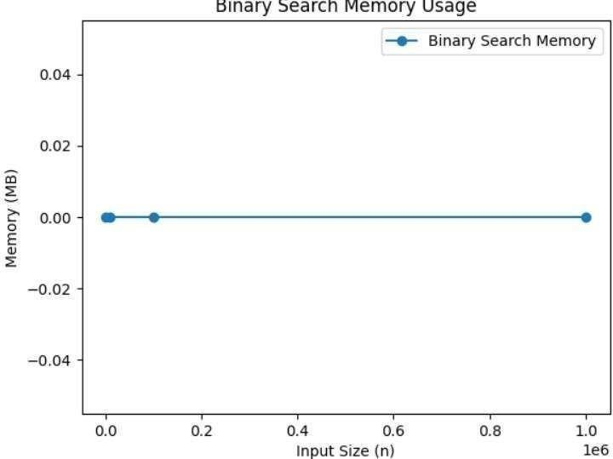
Theoretical Complexity Table
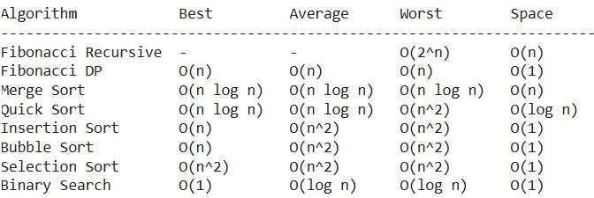
Experimental Results
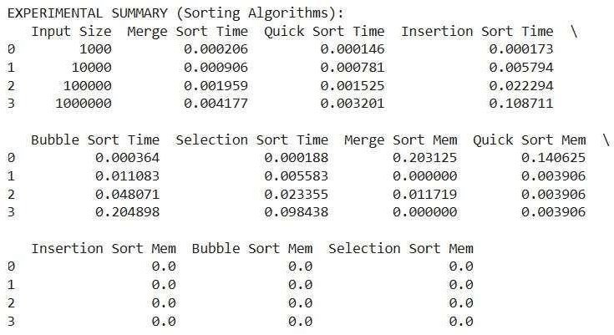
Reflections & Insights

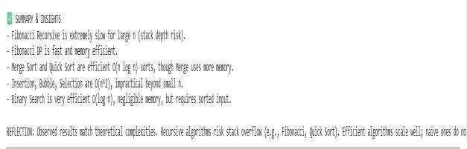
Git hub Repository Link

